5/27/2024

Tebogo Sebola

St10070599

Practical Assignment 2 ADDB6311

Tebogo Sebola St10070599

Question 1

Question 2

Question 3

Question 4

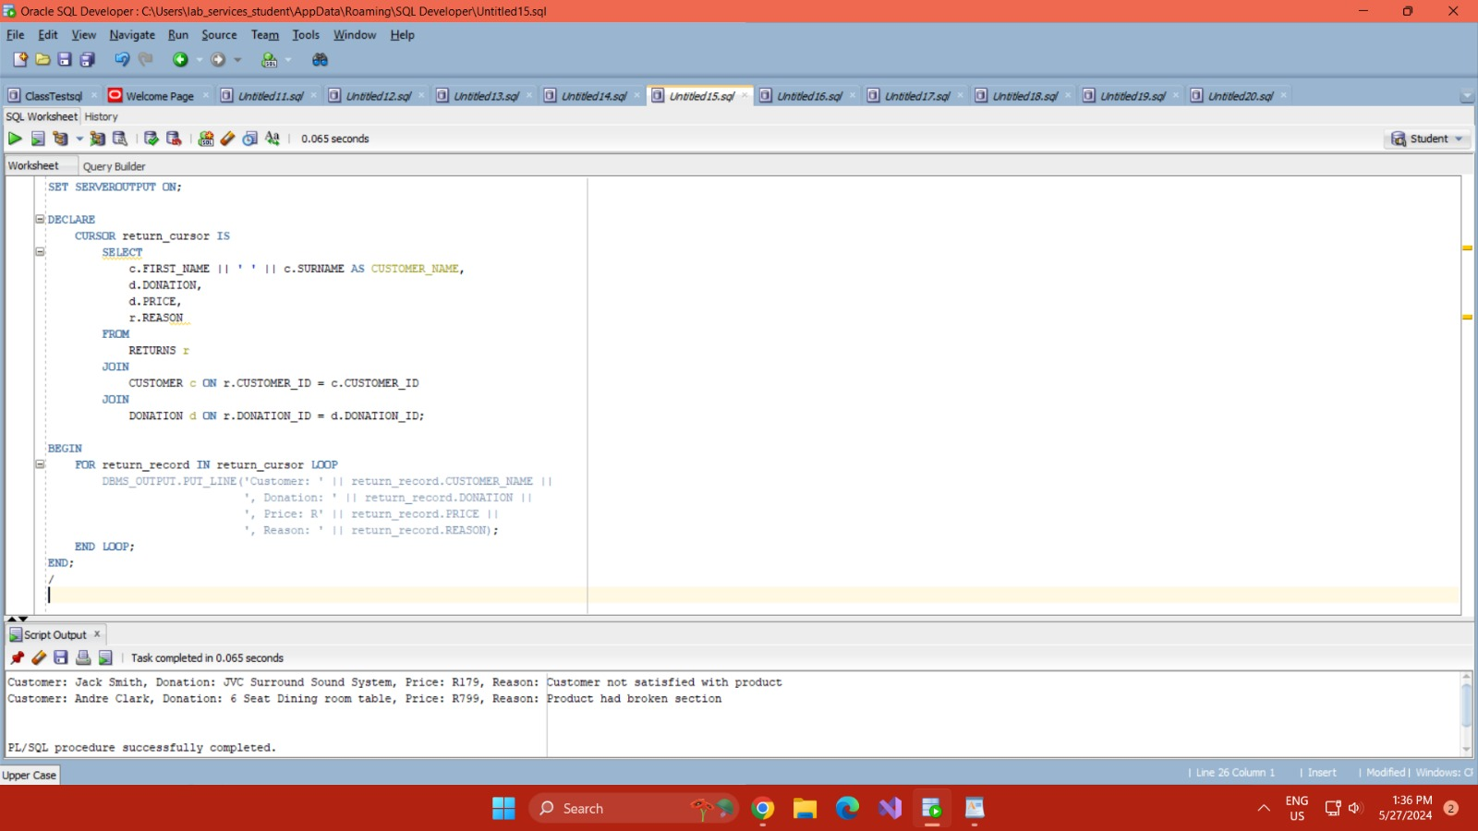

Question 5

Question 6

Question 7

Question 7.1

Question 7.2

Question 7.3

